Connection setup for Trimble TSC2 Controller KYTC cell phone.

Network Connection setup for KYTC Samsung SLM cell phones and the TSC2 controller

1. Make phone discoverable for controller
Samsung SLM
Select Options in the lower right corner by pressing on the – button on the top right of the number pad.

Scroll down to Bluetooth and select (1) Activation. Use the Select option (- button on top left of number pad) and toggle to ON. Select Save by using the – button on the top right of the number pad.

Scroll down to (3) My Phone’s Visibility and follow the same process as above to turn visibility to ON.

*Note: the default name for the Samsung SLM is SGHA747 which can be confusing if there are multiple SLMs in the vicinity when creating a Bluetooth partnership. I recommend creating a unique name for your phone by doing the following:
Scroll down to (4) My Phone’s Name and press the Select option. Enter a name to distinguish this phone from others and select Save.

2. Create a New Partnership
Turn on the controller and select Start>Settings
Select the Connections tab - Select Bluetooth and make sure that the Turn on Bluetooth and Make Device Discoverable are checked.

Select the Devices tab - Select New Partnership: the controller will scan and provide a list of Bluetooth devices available.
Select your phone which will be indicated by SGHA747.

Note: When not using Bluetooth, disable on both the phone and the controller to save your batteries.
Step 1. Setup a New Modem Connection

Turn on Bluetooth on the cell phone and set to discoverable. Turn on the data collector and select Start>Settings>Bluetooth. Select “add new device.” You may be prompted to send a pin number from the collector to the phone and then from the phone to the collector– enter something you will remember like 9999.

Next, select the “Connections” tab at the bottom of the page. Click on the “Connections” icon.

Select “Add a new modem connection” under MY ISP.

In the “Enter a name for the connection:” dialog, key in a name for the connection. If you are using a cable from the phone to the collector, make sure Hayes Compatible on COM1 is selected.
If you are using a Bluetooth phone, Make sure you set this field to Bluetooth. This connection name will be used in Step 2 Create a Dial Profile.

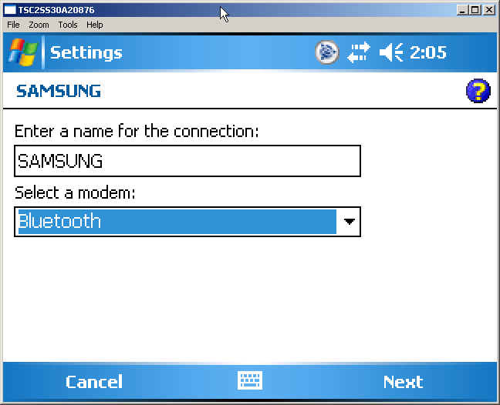

Select “Next” once you have these settings correct.

Enter *99***1# in the number to dial field and select “Next”.
For Verizon service enter #777

If your provider was Cingular and is now AT&T, the User name will be: ISP@CINGULARGPRS.COM and the Password will be: CINGULAR1
Click “Advanced” to continue.
Note:
For Verizon service User name: is your 10 digit cell phone number followed by @vzw3g.com and the password is vzw

Set the Baud rate: to 115200. In the “Extra dial-string modem commands:” key the following string EXACTLY as shown: &f&d2&c1+cgdcont=1,”IP”,”isp.cingular”
For Verizon service the Extra dial-string commands: &C0&D0$QCMDR=3
Note: Some users have encountered modem connection problems using “ISP.Cingular” in the user name and dial string modem command. Substituting WAP for ISP has worked for those who experienced this problem.

Select OK in the upper right hand corner.

Select “Finish”.

Step 2. Create a Dial Profile

In Survey Controller, click on Configuration>Dial profiles and Select the New tab.

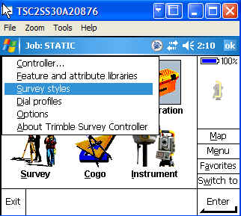

Type in a name for the profile. Select Internet rover as the Profile type. Select the connection name created in Step 1 from the drop down menu under Use connection: - the Bluetooth modem: should automatically populate with the cell phone ID. Select none from the APN: dropdown menu. To connect to the KYCORS server enter 159.19.10.28 in the IP Address: box and 2101 in the IP Port: box. Click on the ½ menu in the lower right corner.

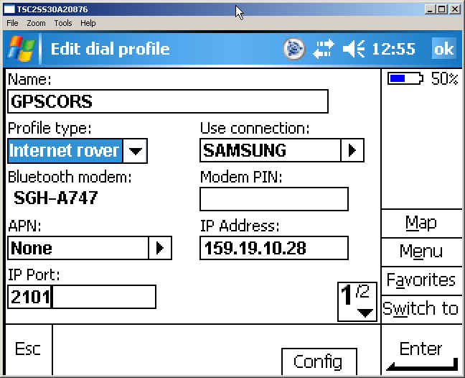
Check the box under Use NTRIP and select GPRS from the Connection type: dropdown menu. Click Enter and save the profile.

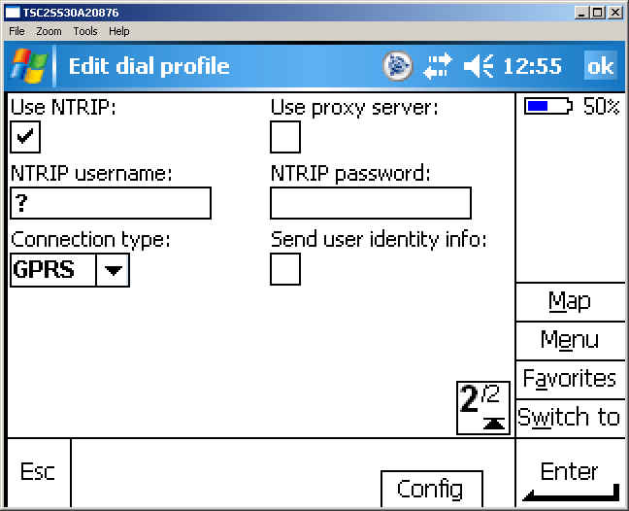
Step 3. Assign a Survey Style

In Survey Controller, click on Configuration>Survey styles.

Select New style and enter a name under Style name: to use the dial profile. Select GPS for the Style type: and click Accept to save settings.

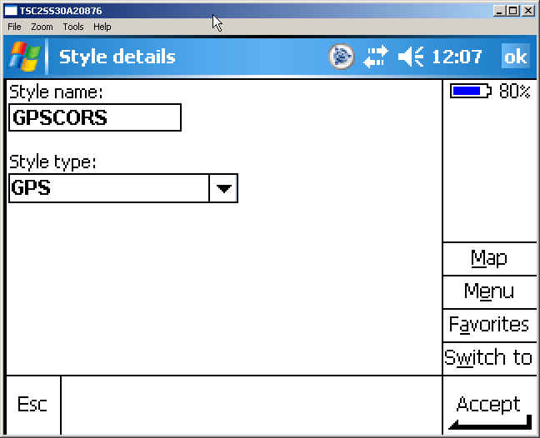

Select Rover options. Set the Survey type: to RTK. Select CMR+ from the Broadcast format: dropdown menu and select Any from the Use station index: dropdown. Click on the ¼ menu in the lower right corner to continue.

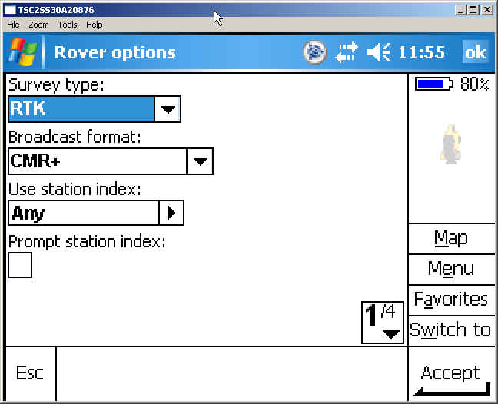

Set Satellite differential: to Off; set Elevation mask: to 10º and the PDOP mask to 6.0. Click on the 2/4 menu in the lower right corner to continue.

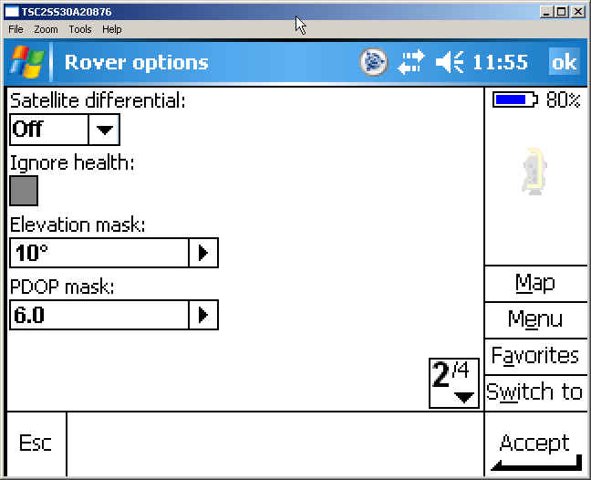

The following settings are typical for KYTC. Select the R8/5800/SPS78x Internal or the R8 Model 2/SPS88x Internal (depending on your receiver model) from the Type: dropdown menu. Select Bottom of antenna mount from the Measured to: dropdown menu. Enter 6.56 for the Antenna height: and click on the right arrow button to select the Units which are survey feet (sft). Click on the 3/4 menu in the lower right corner to continue.

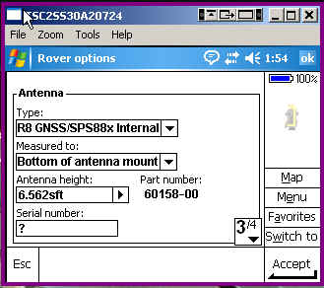

For the 5800 receiver, make sure that Use L2e: is set to Yes. For the R8 also check L2C. For the R8 Model 2 with GLONASS or R6 with GLONASS, also check the GLONASS box. Click Accept to save settings.
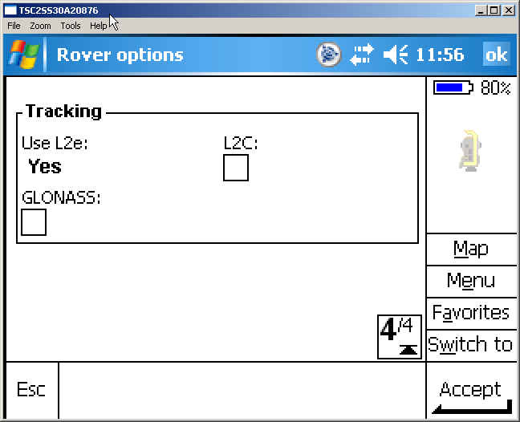
Select “Rover radio” then click on Edit in the lower right corner.

Make sure you have “Type:” set to Internet connection. Under Dial profile: choose the profile used to identify the Bluetooth/Phone connection created in Step 2. Click Accept to save settings..

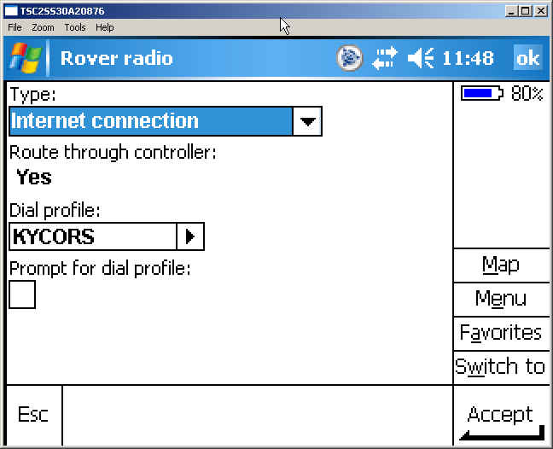

Ntrip Connection for the TSC2

Set the type of survey and the broadcast format in the controller. In this example the broadcast format is set to CMR+ and the survey type is RTK.
For the selected format it is necessary to select the receiving medium for the data. For Ntrip this will be done via Internet connection. It is important to set the correct IP-address and the IP-Port (KYCORS is 159.19.10.28, port 2101), the IP-address links to the selected Broadcaster.

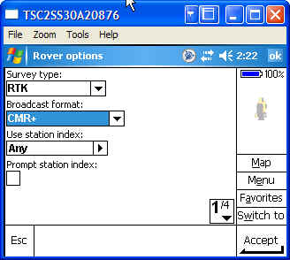

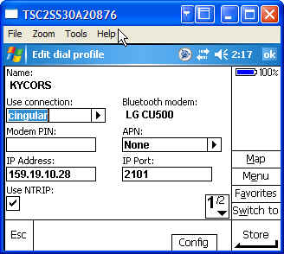

Trimble Survey Controller makes the connection to the cell phone which then makes the internet connection. Once the connection is established the user can start the survey by selecting a predefined Survey Style.
Selecting the Survey Style (e.g. KYCORS) automatically establishes the connection to the defined broadcaster.

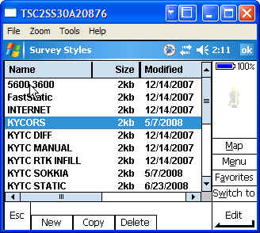

The user is presented with a full list of the available sources for receiving correction data (mount points) within the project area.
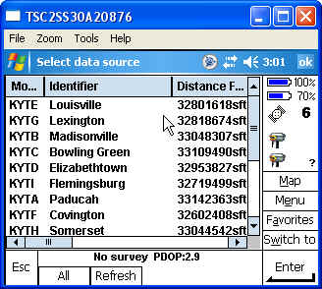

The user simply selects the most appropriate mount point. In addition to the mount points the source list also provides an identifier (typically the location of the reference station), the streamed correction data format details (e.g. CMR+) and the type of solution (e.g. single base).
Once the mount point is selected the software sends out a command to receive correction data, a few seconds later the RTK-GPS Rover will obtain a successful initialization and is ready to commence surveying.

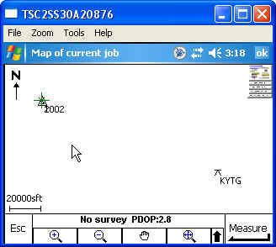

Example of a fixed solution in Trimble Survey Controller using the CORS station KYTG.

Other Cell Phone Tips for Samsung SLM
To avoid having to authorize the blue tooth connection:
From main menu select Options then scroll down to Bluetooth and select
From there scroll down to My Devices and select your controller. With the controller name highlighted, select options and then select number 3 Authorize Device.

